实验九 RSA-AES加密与通讯

9.1 实验目的
RSA加密是一种非对称加密。可以在不直接传递密钥的情况下，完成解密。这能够确保信息的安全性，避免了直接传递密钥所造成的被破解的风险。
AES，高级加密标准，在密码学中又称Rijndael加密法，是美国联邦政府采用的一种区块加密标准。这个标准用来替代原先的DES，已经被多方分析且广为全世界所使用。
然而RSA加密虽然较为安全，但效率较低，只适合于加解密少量数据，AES加密虽然没有RSA那么安全，属于对称加密，但加解密速度很快，适合加解密大量数据。因此为了兼顾效率与安全性，我们选择RSA-AES混合加密。
注：下文与代码中的公私钥指的是RSA加密中的公私钥，秘钥特指AES加密中使用的秘钥。
整个加密传输过程分为以下几个步骤：
- 主机与小车启动通讯程序。
- 小车端读取或生成秘钥（公钥与私钥），并存储，将公钥发送至主机端。
- 主机端接收公钥，生成AES加密使用的私钥，使用公钥对私钥进行加密后，发送至小车端。
- 小车端接收加密后的秘钥，使用私钥进行解密，获取秘钥。
- 主机与小车端的数据使用AES秘钥进行加密。

9.2 实验要求
1、了解RSA-AES加密原理，并尝试对加密过程进行优化。
2、学习使用python的Crypto库对数据进行加解密。
3、合作验证加密是否成功，是否能够进行破解。
4、实验2人一组，课时：4学时
主机环境推荐：Linux虚拟机: Ubuntu20.04， ROS Noetic
小车系统：自带的raspberry pi os , ROS Kinetic（本程序对ROS kinetic 及其 python2进行了适配）

9.3 实验基础知识讲解

9.3.1 RSA加密介绍
1977年，三位数学家Rivest、Shamir 和 Adleman 设计了一种算法，可以实现非对称加密。这种算法用他们三个人的名字命名，叫做RSA算法。从那时直到现在，RSA算法一直是最广为使用的"非对称加密算法"。毫不夸张地说，只要有计算机网络的地方，就有RSA算法。
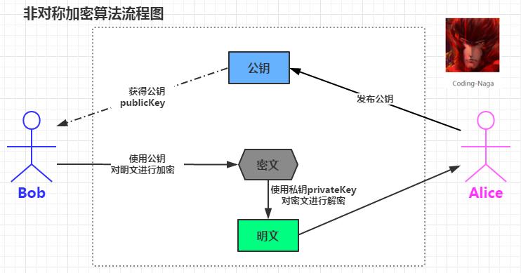
图3-1 非对称加密算法
非对称加密是通过两个密钥（公钥-私钥）来实现对数据的加密和解密的。公钥用于加密，私钥用于解密。
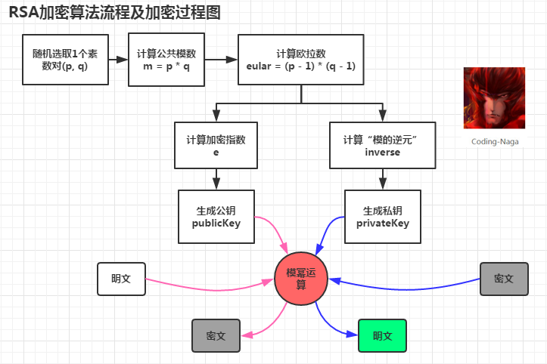
图3-2 RSA加密算法
RSA算法优点
不需要进行密钥传递，提高了安全性
可以进行数字签名认证
RSA算法缺点
加密解密效率不高，一般只适用于处理小量数据（如：密钥）
容易遭受小指数攻击

9.3.2 AES加密介绍
AES含义
AES，高级加密标准，在密码学中又称Rijndael加密法，是美国联邦政府采用的一种区块加密标准。这个标准用来替代原先的DES，已经被多方分析且广为全世界所使用。
严格地说，AES和Rijndael加密法并不完全一样（虽然在实际应用中二者可以互换），因为Rijndael加密法可以支持更大范围的区块和密钥长度：AES的区块长度固定为128 比特，密钥长度则可以是128，192或256比特；
而Rijndael使用的密钥和区块长度可以是32位的整数倍，以128位为下限，256比特为上限。包括AES-ECB，AES-CBC，AES-CTR，AES-OFB，AES-CFB。
AES加密原理
AES加密过程涉及到4种操作，分别是字节替代、行移位、列混淆和轮密钥加。解密过程分别为对应的逆操作。由于每一步操作都是可逆的，按照相反的顺序进行解密即可恢复明文。加解密中每轮的密钥分别由初始密钥扩展得到。算法中16个字节的明文、密文和轮密钥都以一个4x4的矩阵表示。
AES算法特点
运算速度快，安全性高，资源消耗少

9.3.3 pycryptodome库介绍
官方文档网址：https://pycryptodome.readthedocs.io/en/latest/，推荐看英文原版，如果想要快速上手可以直接看Example板块
以下举例一些常规用法：
- 功能包的引入
# 导入AES加密模块
from Crypto.Cipher import AES
# 导入RSA加密模块
from Crypto.PublicKey import RSA
# 导入生成随机秘钥模块
from Crypto.Random import get_random_bytes
# 导入RSA加密方法模块
from Crypto.Cipher import PKCS1_OAEP
- 使用AES进行加解密
# 导入必要模块
from Crypto.Cipher import AES
from Crypto.Random import get_random_bytes

# 原始数据,必须为二进制字节
data = b'secret data'

# 生成AES秘钥,长度为16个字节
key = get_random_bytes(16)

# 生成AES加密工具
cipher = AES.new(key, AES.MODE_EAX)

# 进行加密, ciphertext为加密后的信息， tag为加密特征码（解密时需要），nonce也是解密时需要
ciphertext, tag = cipher.encrypt_and_digest(data)
nonce = cipher.nonce

# 解密时需要秘钥，tag和nonce,三者缺一不可，需要在传输时进行封装
decrypt = AES.new(key, AES.MODE_EAX, nonce)

# 进行解密
data2 = decrypt.decrypt_and_verify(ciphertext, tag)
解密后数据恢复
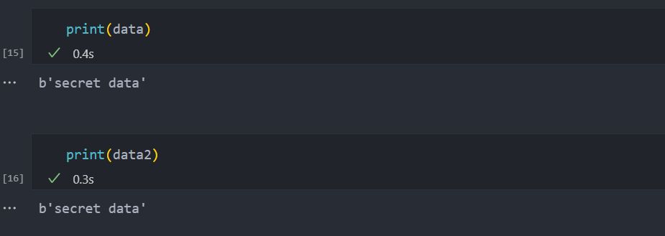

- 生成RSA公私钥
# 导入RSA库
from Crypto.PublicKey import RSA

# 生成RSA秘钥
key = RSA.generate(1024)

# 导出私钥
private_key = key.export_key()

# 导出公钥
public_key = key.publickey().export_key()

生成的私钥和公钥如图所示
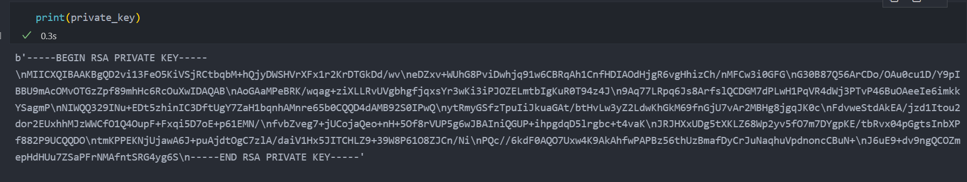
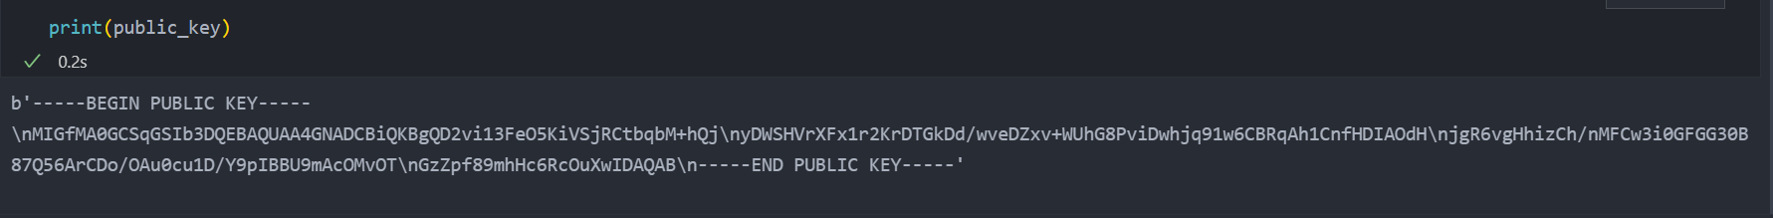
- 使用RSA-AES混合进行加解密
为了对任意大小的数据进行加解密，我们使用RSA-AES进行混合加解密
默认已经获取了前面生成的RSA的公私钥和AES的秘钥
# 导入库
from Crypto.PublicKey import RSA
from Crypto.Random import get_random_bytes
from Crypto.Cipher import AES, PKCS1_OAEP

# 原始数据
data = "I met aliens in UFO. Here is the map.".encode('utf-8')

# 对AES秘钥进行RSA加密
cipher_rsa = PKCS1_OAEP.new(RSA.import_key(public_key))
enc_key = cipher_rsa.encrypt(key)

# 对数据进行AES加密
cipher_aes = AES.new(key, AES.MODE_EAX)
ciphertext, tag = cipher_aes.encrypt_and_digest(data)

# 将加密后的秘钥（可以在建立连接时只传输一次），nonce，tag和加密后的数据一起传输出去
message = enc_key + cipher_aes.nonce + tag + ciphertext
解密：
假设已经获取了私钥
注意nonce和tage的长度均为16
# 导入库
from Crypto.PublicKey import RSA
from Crypto.Cipher import AES, PKCS1_OAEP

# 生成RSA解密工具
cipher_rsa = PKCS1_OAEP.new(RSA.import_key(private_key))

# 解密AES秘钥
key = cipher_rsa.decrypt(enc_key)

# 使用AES秘钥解密数据
cipher_aes = AES.new(key, AES.MODE_EAX, nonce)
data2 = cipher_aes.decrypt_and_verify(ciphertext, tag)
解密后
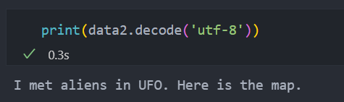

9.4 实验步骤
gitee仓库：https://gitee.com/IcathianRain/rsa--aes-encryption

9.4.1 主机端功能包
1、安装python PyCryptodome库
pip install pycryptodome
若安装较慢可使用清华源
pip install pycryptodome -i https://pypi.tuna.tsinghua.edu.cn/simple
- 编写功能包
文件结构
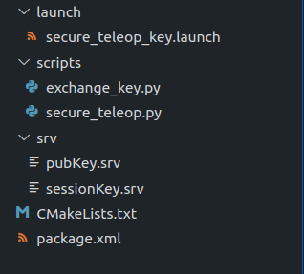
配置工作空间
mkdir -p catkin_ws/src
cd catkin_ws/src
catkin_init_workspace

创建主机端功能包
catkin_create_pkg secure_teleop_remote roscpp rospy std_msgs geometry_msgs message_generation
cd secure_teleop_remote

初始化功能包
mkdir scripts
mkdir launch
mkdir srv

在srv目录下新建sessionKey.srv和pubKey.srv
sessionKey.srv文件内容
uint8[] sessionKey

---
bool flag0
pubKey.srv文件内容
uint8[] pubKey

---
bool flag1

在launch目录下新建secure_teleop_remote.launch
在scripts目录下新建exchange_key.py和secure_teleop.py
修改CMakeLists.txt和package.xml与gitee仓库一致
第一次编译文件
返回到caktin_ws目录下
catkin_make
scripts/exchange_key.py 文件内容如下：

#!/usr/bin/env python3
# -*- coding: utf-8 -*-

import rospy # 导入ROS模块
import os # 导入os模块
from secure_teleop_remote.srv import * # 导入自定义的服务
from Crypto.Cipher import AES, PKCS1_OAEP
from Crypto.Random import get_random_bytes
from Crypto.PublicKey import RSA

# 全局变量声明
session_key = b'' # AES加密使用秘钥
enc_session_key = b'' # RSA加密后的秘钥

# 保存秘钥
def generate_and_store_session_key():
global session_key
# 生成秘钥
session_key = get_random_bytes(16)
# 保存秘钥至 ~/Key1/session_key.pem

with open('session_key.pem', 'wb') as e:
e.write(session_key)

# 接受小车传来的公钥
# 使用公钥对秘钥进行加密
def handle_receive_public_key(req: pubKeyRequest):
global enc_session_key
public_key = req.pubKey # 获取公钥
print('成功接受公钥')
# 使用公钥对秘钥进行加密
recipient_key = RSA.import_key(public_key)
cipher_rsa = PKCS1_OAEP.new(recipient_key)
enc_session_key = cipher_rsa.encrypt(session_key)
return pubKeyResponse(True)

def send_enc_session_key():
# 将加密的密钥发送出去
rospy.wait_for_service('exchangeSessionKey')
try:
send = rospy.ServiceProxy('exchangeSessionKey', sessionKey)
msg = sessionKeyRequest()
msg.sessionKey = enc_session_key
resp = send(msg)
if(resp.flag0 == True):
print('成功发出秘钥')
except rospy.ServiceException as e:
print("Service call failed: %s" % e)
rospy.spin()

if __name__ == '__main__':
# 进入秘钥保存目录
home = os.path.expanduser("~")
try:
os.chdir(home + "/Key1")
except:
os.mkdir(home + "/Key1")
os.chdir(home + "/Key1")
# 初始化节点
rospy.init_node('remote_key')
generate_and_store_session_key()
# 接受公钥
s = rospy.Service('exchangePubKey', pubKey, handler=handle_receive_public_key)
print('等待公钥传输.....')
send_enc_session_key()
scripts/secure_teleop.py文件内容如下:
#!/usr/bin/env python3
# -*- coding: utf-8 -*-

# 开源说明
# Copyright (c) 2011, Willow Garage, Inc.
# All rights reserved.
#
# Redistribution and use in source and binary forms, with or without
# modification, are permitted provided that the following conditions are met:
#
# * Redistributions of source code must retain the above copyright
# notice, this list of conditions and the following disclaimer.
# * Redistributions in binary form must reproduce the above copyright
# notice, this list of conditions and the following disclaimer in the
# documentation and/or other materials provided with the distribution.
# * Neither the name of the Willow Garage, Inc. nor the names of its
# contributors may be used to endorse or promote products derived from
# this software without specific prior written permission.
#
# THIS SOFTWARE IS PROVIDED BY THE COPYRIGHT HOLDERS AND CONTRIBUTORS "AS IS"
# AND ANY EXPRESS OR IMPLIED WARRANTIES, INCLUDING, BUT NOT LIMITED TO, THE
# IMPLIED WARRANTIES OF MERCHANTABILITY AND FITNESS FOR A PARTICULAR PURPOSE
# ARE DISCLAIMED. IN NO EVENT SHALL THE COPYRIGHT OWNER OR CONTRIBUTORS BE
# LIABLE FOR ANY DIRECT, INDIRECT, INCIDENTAL, SPECIAL, EXEMPLARY, OR
# CONSEQUENTIAL DAMAGES (INCLUDING, BUT NOT LIMITED TO, PROCUREMENT OF
# SUBSTITUTE GOODS OR SERVICES; LOSS OF USE, DATA, OR PROFITS; OR BUSINESS
# INTERRUPTION) HOWEVER CAUSED AND ON ANY THEORY OF LIABILITY, WHETHER IN
# CONTRACT, STRICT LIABILITY, OR TORT (INCLUDING NEGLIGENCE OR OTHERWISE)
# ARISING IN ANY WAY OUT OF THE USE OF THIS SOFTWARE, EVEN IF ADVISED OF THE
# POSSIBILITY OF SUCH DAMAGE.

import rospy # 导入 rospy 模块
import time
from std_msgs.msg import Int16MultiArray # 导入 Int16MultiArray 消息类型, 存放密文
from geometry_msgs.msg import Twist # 导入 Twist 消息类型， 存放机器人的速度
import sys, select, os # 导入 sys, select, os 模块

if os.name == "nt": # 如果是 Windows 系统
import msvcrt # 导入 msvcrt 模块
else: # 否则
import tty, termios # 导入 tty, termios 模块

# 导入 AES 加密库
from Crypto.Cipher import AES

BURGER_MAX_LIN_VEL = 0.22
BURGER_MAX_ANG_VEL = 2.84

WAFFLE_MAX_LIN_VEL = 0.26
WAFFLE_MAX_ANG_VEL = 1.82

LIN_VEL_STEP_SIZE = 0.01
ANG_VEL_STEP_SIZE = 0.1
# 开始提示信息
start_msg = """
Start to connect and get the Public_key
-----------------------------------------
"""

# 收到秘钥后的提示信息
end_msg = """
Got the Public_key!
----------------------------------
"""

# 操控机器人的提示信息
msg = """
Control Your TurtleBot3!
---------------------------
Moving around:
w
a s d
x

w/x : increase/decrease linear velocity (Burger : ~ 0.22, Waffle and Waffle Pi : ~ 0.26)
a/d : increase/decrease angular velocity (Burger : ~ 2.84, Waffle and Waffle Pi : ~ 1.82)

space key, s : force stop

CTRL-C to quit
"""

e = """
Communications Failed
"""

def getKey():
if os.name == "nt":
if sys.version_info[0] >= 3:
return msvcrt.getch().decode()
else:
return msvcrt.getch()

tty.setraw(sys.stdin.fileno())
rlist, _, _ = select.select([sys.stdin], [], [], 0.1)
if rlist:
key = sys.stdin.read(1)
else:
key = ""

termios.tcsetattr(sys.stdin, termios.TCSADRAIN, settings)
return key

def vels(target_linear_vel, target_angular_vel):
return "currently:\tlinear vel %s\t angular vel %s " % (
target_linear_vel,
target_angular_vel,
)

def makeSimpleProfile(output, input, slop):
if input > output:
output = min(input, output + slop)
elif input < output:
output = max(input, output - slop)
else:
output = input

return output

def constrain(input, low, high):
if input < low:
input = low
elif input > high:
input = high
else:
input = input

return input

def checkLinearLimitVelocity(vel):
if turtlebot3_model == "burger":
vel = constrain(vel, -BURGER_MAX_LIN_VEL, BURGER_MAX_LIN_VEL)
elif turtlebot3_model == "waffle" or turtlebot3_model == "waffle_pi":
vel = constrain(vel, -WAFFLE_MAX_LIN_VEL, WAFFLE_MAX_LIN_VEL)
else:
vel = constrain(vel, -BURGER_MAX_LIN_VEL, BURGER_MAX_LIN_VEL)

return vel

def checkAngularLimitVelocity(vel):
if turtlebot3_model == "burger":
vel = constrain(vel, -BURGER_MAX_ANG_VEL, BURGER_MAX_ANG_VEL)
elif turtlebot3_model == "waffle" or turtlebot3_model == "waffle_pi":
vel = constrain(vel, -WAFFLE_MAX_ANG_VEL, WAFFLE_MAX_ANG_VEL)
else:
vel = constrain(vel, -BURGER_MAX_ANG_VEL, BURGER_MAX_ANG_VEL)

return vel

# 读取秘钥
def getSessionKey():
try: # 尝试导入秘钥
home = os.path.expanduser("~")
# 打开公钥文件
with open(home + "/Key1/session_key.pem", "rb") as x:
session_key = x.read() # 读取秘钥
except:
rospy.signal_shutdown("There is not a Session_key") # 如果没有密钥，则退出
else:
return session_key # 如果有密钥，则返回密钥

# 对msg进行加密
def Encrypt(msg, session_key):
cipher = AES.new(session_key, AES.MODE_EAX)
ciphertext, tag = cipher.encrypt_and_digest(msg)
# 密文为 nonce(长度16) + tag(长度16) + 加密后数据(长度未知)
ciphertext = cipher.nonce + tag + ciphertext
return (ciphertext) # 返回加密内容

if __name__ == "__main__":
if os.name != "nt":
settings = termios.tcgetattr(sys.stdin)

rospy.init_node("secure_teleop") # 初始化ROS节点
# 若success 不为True 则阻塞在这里
while rospy.get_param("success", False) != True:
time.sleep(1)
pass
# pub = rospy.Publisher('cmd_vel', Twist, queue_size=10)
print('秘钥交换成功')
# 关闭交换秘钥节点
os.system("rosnode kill /remote_key")
os.system("rosnode kill /robot_key")
# 创建 Publisher 发布密文
pub = rospy.Publisher("Cypered_cmd_vel", Int16MultiArray, queue_size=10)
# 设置模型
turtlebot3_model = rospy.get_param("model", "burger")

status = 0
target_linear_vel = 0.0
target_angular_vel = 0.0
control_linear_vel = 0.0
control_angular_vel = 0.0

try:
print(start_msg)
session_key = getSessionKey()
print(end_msg)
print(msg)
while 1:
key = getKey()
# 获取键盘输入
if key == "w":
target_linear_vel = checkLinearLimitVelocity(
target_linear_vel + LIN_VEL_STEP_SIZE
)
status = status + 1
print(vels(target_linear_vel, target_angular_vel))
elif key == "x":
target_linear_vel = checkLinearLimitVelocity(
target_linear_vel - LIN_VEL_STEP_SIZE
)
status = status + 1
print(vels(target_linear_vel, target_angular_vel))
elif key == "a":
target_angular_vel = checkAngularLimitVelocity(
target_angular_vel + ANG_VEL_STEP_SIZE
)
status = status + 1
print(vels(target_linear_vel, target_angular_vel))
elif key == "d":
target_angular_vel = checkAngularLimitVelocity(
target_angular_vel - ANG_VEL_STEP_SIZE
)
status = status + 1
print(vels(target_linear_vel, target_angular_vel))
elif key == " " or key == "s":
target_linear_vel = 0.0
control_linear_vel = 0.0
target_angular_vel = 0.0
control_angular_vel = 0.0
print(vels(target_linear_vel, target_angular_vel))
else:
if key == "\x03":
break

if status == 20:
print(msg)
status = 0

# 创建运动指令
twist = Twist()
# 设置线速度
control_linear_vel = makeSimpleProfile(
control_linear_vel, target_linear_vel, (LIN_VEL_STEP_SIZE / 2.0)
)
twist.linear.x = control_linear_vel
twist.linear.y = 0.0
twist.linear.z = 0.0
# 设置角速度
control_angular_vel = makeSimpleProfile(
control_angular_vel, target_angular_vel, (ANG_VEL_STEP_SIZE / 2.0)
)
twist.angular.x = 0.0
twist.angular.y = 0.0
twist.angular.z = control_angular_vel
# 创建运动信息 linear.x + " " + angular.z
str_msg = str(twist.linear.x) + " " + str(twist.angular.z)
print(str_msg) # 打印运动信息
cipher_msg = Int16MultiArray() # 创建密文载体
cipher_msg.data = list(Encrypt(str_msg.encode("ASCII"), session_key)) # 加密信息
pub.publish(cipher_msg) # 发布密文

except:
print(e)

finally:
# 结束时，恢复静止状态
twist = Twist()
twist.linear.x = 0.0
twist.linear.y = 0.0
twist.linear.z = 0.0
twist.angular.x = 0.0
twist.angular.y = 0.0
twist.angular.z = 0.0
str_msg = str(twist.linear.x) + " " + str(twist.angular.z) # 创建运动信息
cipher_msg = Int16MultiArray() # 创建密文载体
cipher_msg.data = list(Encrypt(str_msg.encode('UTF-8'), session_key)) # 加密信息
print(cipher_msg.data)
pub.publish(cipher_msg) # 发布密文

if os.name != "nt": # 判断是否为windows系统
termios.tcsetattr(sys.stdin, termios.TCSADRAIN, settings)
launch/secure_teleop_key.launch文件内容如下:
<launch>
<arg name="model" default="$(env TURTLEBOT3_MODEL)" doc="model type [burger, waffle, waffle_pi]"/>
<param name="model" value="$(arg model)"/>
<param name="success" value="false" />

<node pkg="secure_teleop_remote" type="exchange_key.py" name="remote_key" output="screen">
</node>
<!-- turtlebot3_teleop_key already has its own built in velocity smoother -->
<node pkg="secure_teleop_remote" type="secure_teleop.py" name="secure_teleop_keyboard" output="screen">
</node>
</launch>

9.4.2 小车端功能包
1、安装python PyCryptodome库
pip install pycryptodome
若安装较慢可使用清华源
pip install pycryptodome -i https://pypi.tuna.tsinghua.edu.cn/simple
- 编写功能包
若小车端编写代码困难，可在主机上编写代码后复制过去，故在主机的同一个工作空间内编写

文件结构
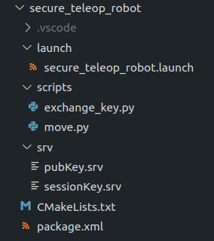
创建功能包
cd ~/catkin_ws/src
catkin_create_pkg secure_teleop_robot roscpp rospy std_msgs geometry_msgs message_generation
初始化功能包
mkdir scripts
mkdir launch
mkdir srv

在srv目录下新建sessionKey.srv和pubKey.srv
sessionKey.srv文件内容
uint8[] sessionKey

---
bool flag0
pubKey.srv文件内容
uint8[] pubKey

---
bool flag1
在launch目录下新建secure_teleop_robot.launch
在scripts目录下新建exchange_key.py和move.py
修改CMakeLists.txt和package.xml与gitee仓库一致

scripts/exchange_key.py 文件内容如下:
#!/usr/bin/env python
# -*- coding: utf-8 -*-
from cgitb import handler
import os
from Crypto.PublicKey import RSA
from secure_teleop_robot.srv import *
import rospy
from Crypto.Cipher import PKCS1_OAEP

private_key = b''
public_key = b''
session_key = b''

def generate_and_store_key():
global public_key
global private_key
# 生成或读取RSA公私钥
try:
f = open("public.pem", "rb")
except:
key = RSA.generate(1024)
private_key = key.export_key()
public_key = key.publickey().export_key()
with open("private.pem", "wb") as x:
x.write(private_key)
with open("public.pem", "wb") as x:
x.write(public_key)
f = open("public.pem", "rb")
else:
public_key = f.read()
f.close()

def send_pubKey(public_key):
rospy.wait_for_service('exchangePubKey')
print('正在发送公钥')
try:
send = rospy.ServiceProxy('exchangePubKey', pubKey)
msg = pubKeyRequest()
msg.pubKey = public_key
resp = send(msg)
return resp.flag1
except rospy.ServiceException as e:
print("Service call failed: %s" % e)

def handle_receive_sessionKey(req: sessionKeyRequest):
global private_key
print('已接收秘钥')
enc_session_key = req.sessionKey
# 获取撕咬
with open('private.pem', 'rb') as e:
private_key = RSA.import_key(e.read())
cipher_rsa = PKCS1_OAEP.new(private_key)
session_key = cipher_rsa.decrypt(enc_session_key)
# 保存秘钥
with open('session_key.pem', 'wb') as e:
e.write(session_key)
rospy.set_param("success", True)
return sessionKeyResponse(True)

if __name__ == '__main__':
# 进入公私钥与秘钥保存空间
home = os.path.expanduser("~")
try:
os.chdir(home + "/Key0")
except:
os.mkdir(home + "/Key0")
os.chdir(home + "/Key0")
# 初始化节点
rospy.init_node('robot_key')
# 生成公私钥并保存至 ~/Key0
generate_and_store_key()
# 发送公钥
send_pubKey(public_key)
# 使用私钥对秘钥进行解密
s = rospy.Service('exchangeSessionKey', sessionKey, handler=handle_receive_sessionKey)
print('等待秘钥传输')
rospy.spin()
scripts/move.py 文件内容如下:
#! /usr/bin/env python
# -*- coding: utf-8 -*-
import os
import rospy
from std_msgs.msg import Int16MultiArray
from geometry_msgs.msg import Twist
from Crypto.Cipher import AES

def get_session_key():
try:
home = os.path.expanduser("~")
with open(home + "/Key0/session_key.pem", "rb") as x:
session_key = x.read()
except:
rospy.signal_shutdown("There is not a Session_key")
else:
return session_key

def callback(cipher_text, arg):
pub = arg[0]
session_key = arg[1]
ciphermsg = bytearray(cipher_text.data)
print(ciphermsg)
# nonce 为密文0-15
nonce = ciphermsg[:16]
# tag 为密文16-31
tag = ciphermsg[16:32]
cipher_aes = AES.new(session_key, AES.MODE_EAX, nonce)
# print(nonce, tag)
# 密文为 32-最后
msg = cipher_aes.decrypt_and_verify(ciphermsg[32:], tag).decode('ASCII')
# print(msg)
x, z = msg.split(" ")
print("x:{}".format(float(x)))
print("z:{}".format(float(z)))
twist = Twist()
twist.linear.x = float(x)
twist.angular.z = float(z)
twist.linear.y = 0.0
twist.linear.z = 0.0
twist.angular.x = 0.0
twist.angular.y = 0.0
pub.publish(twist)

if __name__ == '__main__':
rospy.init_node('move')
# 等待结果
while rospy.get_param("success", False) != True:
pass
print('秘钥交换完成')
session_key = get_session_key()
pub = rospy.Publisher('cmd_vel', Twist, queue_size=10)
rospy.Subscriber("Cypered_cmd_vel", Int16MultiArray, callback,callback_args=(pub, session_key), queue_size=1)
rospy.spin()
launch/secure_teleop_robot.launch文件内容如下:
<launch>
<param name="success" value="false"/>
<node pkg="secure_teleop_robot" type="exchange_key.py" name="robot_key" output="screen">
</node>
<node pkg="secure_teleop_robot" type="move.py" name="move" output="screen">
</node>
</launch>

9.4.3运行程序
在主机端编译此功能包
cd ~/catkin_ws
catkin_make
source devel/setup.bash
运行主机launch文件
roslaunch secure_teleop_remote secure_teleop_key.launch

在小车端编译此功能包
cd ~/catkin_ws
catkin_make
source devel/setup.bash
运行主机launch文件
roslaunch secure_teleop_robot secure_teleop_robot.launch

